Title: IoT Based Pearl Farm Health Regulator
Dr.Prof.Jayashree Prashant Kharat
Professor
DKTE’s Society’sTextile and Engineering Institute, Ichalakranji.
jpkharat@dkte.ac.in
Ms. Savita Sidram Totad
Student
DKTE’s Society’s Textile and Engineering Institute, Ichalakranji.
etcsstotad@dkte.ac.in
Mr. Swaroop Bharat Thikane
Student
DKTE’s Society’s Textile and Engineering Institute, Ichalakranji.
etcsbthikane@dkte.ac.in
Ms. Vaishnavi Raju Pawar
Student
DKTE’s Society’s Textile and Engineering Institute, Ichalakranji.
etcvrpawar@dkte.ac.in
Mr. Atharav Ramchandra Todakar
Student
DKTE’s Society’s Textile and Engineering Institute, Ichalakranji.
etcartodkar@dkte.ac.in

Mr. Vedant Vishwanath Joshi
Student
DKTE’s Society’s Textile and Engineering Institute, Ichalakranji.
etcvvjoshi@dkte.ac.in

Abstract—
Pearl farming is a vital part of India’s aquaculture industry, yet it continues to face challenges due to outdated practices and technological limitations. This paper presents an innovative IoT-based Pearl Farm Health Regulator designed to automate critical processes such as water quality monitoring, feeding schedules, and real-time data analysis. By integrating sensors, machine learning algorithms, and cloud-based platforms, this system ensures an optimal environment for pearl production while reducing manual labor. The proposed system addresses key inefficiencies in traditional farming methods, helping to increase yield, improve pearl quality, and enhance sustainability. With India's pearl farming sector struggling to meet domestic demand, the introduction of this technology offers a scalable solution to elevate the industry’s productivity and global competitiveness.
Keywords: Pearl Farming, IoT-based Automation, Water Quality Monitoring, Sustainable Pearl Production, Smart Farming Technologies

Introduction
Pearl farming, an integral part of aquaculture, has been practiced for centuries to produce one of nature's most exquisite gems. However, it remains a labor intensive and highly sensitive process, requiring meticulous attention to environmental conditions and resource management. Pearls, formed by oysters, demand an optimal habitat— precisely balanced water quality, controlled feeding schedules, and minimal stress—to ensure their health and the production of high quality pearls. Despite India’s favorable climatic conditions and rich aquaculture potential, the pearl farming industry has struggled to achieve its full capacity due to traditional, outdated practices and the lack of technological integration.
A significant challenge in pearl farming is the maintenance of water quality parameters such as pH, total dissolved solids (TDS), and dissolved oxygen levels. These parameters, if not consistently regulated, can lead to oyster stress, disease, and even mortality, directly impacting the yield and quality of pearls. Similarly, feeding practices, traditionally done manually, are prone to inefficiencies, resulting in either underfeeding or overfeeding. These challenges are further compounded by the limited availability of skilled labor and the growing demand for sustainable and high quality pearls in both domestic and international markets.
India, despite being a major consumer of pearls, imports a substantial portion of its supply due to the inadequate productivity of its domestic pearl farms. This dependency not only drains foreign exchange but also leaves Indian farmers unable to compete in the global market. Moreover, traditional methods often neglect environmental sustainability, leading to overuse of resources and ecological imbalance, further threatening the long term viability of the industry.
In response to these challenges, this paper proposes the IoT Based Pearl Farm Health Regulator as a transformative solution. This conceptual system is designed to build Internet of Things (IoT) technology to automate critical processes such as water quality monitoring, feeding schedules, and real time data analysis. By integrating sensors, machine learning algorithms, and cloud based platforms, the proposed system aims to enable farmers to maintain optimal farming conditions with minimal effort. In addition to providing a stable and conducive environment for oysters, the proposed system envisions a user friendly interface tailored to farmers with limited technical expertise. Through intuitive visualizations and remote access via a mobile app, it aims to empower farmers to monitor, control, and optimize their farms efficiently. By bridging the gap between traditional practices and modern technology, this innovation has the potential to ensure increased productivity, economic sustainability, and environmental stewardship. This paper outlines the necessity, design, and potential impact of this proposed system, highlighting its ability to transform India’s pearl farming industry into a globally competitive sector.

Existing Scenario of Pearl Farming in India
India, blessed with extensive aquatic resources and favorable climatic conditions, possesses immense potential to become a global leader in pearl farming. However, the sector remains underdeveloped, hindered by traditional Practices, technological constraints, and a reliance on imports to meet domestic demand. This section provides a critical analysis of the current state of pearl farming in India, aligning with the background and motivations for the proposed IoT based system.

Traditional Practices: A major Bottleneck
Pearl farming in India predominantly relies on traditional, manual techniques, which are resource intensive and prone to inefficiencies. The production of pearls is largely dominated by small scale, artisanal operations rather than commercially scalable ventures. Among the three types of pearls—natural, cultured, and freshwater—cultured pearls constitute the majority of domestic production. These pearls are cultivated by surgically implanting a nucleus into oysters, which subsequently secrete nacre to form pearls. While globally advanced techniques have improved the efficiency and yield of pearl farming, Indian farmers continue to face challenges in adopting these innovations due to limited access to modern tools, technical training, and infrastructure.
The lack of modernization not only restricts production capacity but also impacts the quality of pearls, rendering Indian farmers less competitive in the international market.onfirm that you have the correct template for your paper size. This template has been tailored for output on the A4 paper size. If you are using US letter-sized paper, please close this file and download the Microsoft Word, Letter file.

Dependence on Imports
India is one of the largest consumers of pearls, with demand driven by cultural, ornamental, and religious uses. However, domestic production remains insufficient, necessitating heavy reliance on imports from countries such as: China: The global leader in freshwater pearl farming, known for its high yield production supported by advanced aquaculture technologies. Japan: Renowned for premium quality Akoya and South Sea pearls, which are highly sought after in the luxury market.
This dependency not only creates a significant trade imbalance but also undermines the economic potential of India's aquaculture sector. Addressing this reliance requires a shift toward modern; technology driven pearl farming practices that can increase domestic production.

Low Technology Penetration
One of the most pressing challenges in India’s pearl farming industry is the minimal adoption of technology. Critical aspects such as:
- Water Quality Monitoring: Currently handled manually, often leading to inconsistencies and delayed responses to adverse conditions.
- Disease Management: Lacking precise tools for early detection, which increases the risk of oyster mortality.
- Feeding Practices: Inefficient manual feeding methods result in overfeeding, underfeeding, or wastage of resources.
Without the integration of advanced systems like IoT based solutions, Indian farmers are unable to achieve the precision and scalability required to enhance yield and quality.

Government Interventions
Recognizing the potential of pearl farming, the Indian government and agricultural organizations have initiated several measures to promote the sector, including:
- Training Programs: Providing knowledge of modern pearl culture techniques.
- Subsidies and Financial Aid: Encouraging small scale farmers to consider pearl farming as a viable livelihood option.
- Research and Development: Institutions like the Central Institute of Freshwater Aquaculture (CIFA) are working to improve cultivation techniques.
While these initiatives are commendable, their impact remains limited due to the slow pace of adoption and implementation.

Geographical Concentration
Pearl farming in India is concentrated in a few key regions, which highlights the uneven development of the sector: Andhra Pradesh: A leading hub for freshwater pearl farming due to its favorable water bodies and climatic conditions.
Kerala and Tamil Nadu: Regions exploring marine pearl farming, leveraging their coastal ecosystems. Odisha and West Bengal: Emerging players with untapped potential for expansion.
This regional focus underscores the need for a more distributed and scalable approach to pearl farming across the country.

Market Dynamics and Consumer Demand
India’s strong domestic demand for pearls is fueled by:
• Jewelry Industry: Pearls are integral to traditional and modern jewelry designs.
• Cultural and Religious Significance: Widely used in rituals and as offerings in temples.
• Fashion Trends: Increasingly popular in contemporary accessories, driving demand among younger consumers.
Despite robust demand, domestic production falls short, leading to higher prices and reduced accessibility for consumers.

Opportunities for Growth
Despite its current challenges, the pearl farming sector in India holds significant potential for growth:
- Natural Resources: India’s abundant freshwater and marine ecosystems provide a solid foundation for large-scale pearl farming.
- Technological Advancements: Emerging IoT-based solutions can address inefficiencies and enhance productivity.
- Global Market Entry: With improved production quality and quantity, India can compete in the global pearl market, reducing dependency on imports and increasing export opportunities.
The need for technological intervention is evident in overcoming existing limitations and inefficiencies in pearl farming practices. Next, the paper will explore the design and implementation of the proposed IoT-based solution for optimizing pearl production.

Overview Of Existing Technology
In the realm of freshwater pearl farming, only one IoT-based system specifically designed for freshwater pearl management has been reported in the literature. However, significant advancements have been made in IoT and machine learning (ML)-based systems for aquaculture and aquatic life management. This section provides a concise survey of existing work in this domain, highlighting progress and gaps in the field.
Singh et al. [1] proposed an IoT-based system for recirculating aquaculture, incorporating sensors to monitor water parameters like pH, dissolved oxygen (DO), and temperature. Using machine learning models such as Random Forest (RF) and M5 Model Tree, they demonstrated accurate water quality forecasting, with the M5 Model Tree showing superior performance. Edge and fog computing enabled real-time monitoring, ensuring sustainability in aquaculture practices. Similarly, Santhiya et al. [7] utilized RF algorithms in an FPGA-based IoT system for freshwater aquaculture, enhancing sustainability.
Chiu et al. [2] developed a smart aquaculture management system integrating IoT and AI-based surrogate models. Their deep learning (DL) model, optimized using Bayesian techniques, achieved high predictive accuracy for fish growth, facilitating better feed utilization and water quality management while reducing manual labor.
Kumar et al. [3] introduced a cost-effective IoT monitoring system using the Blynk platform for real-time visualization and control. This system employed sensors for parameters like pH, turbidity, temperature, and water level, transmitting data via Arduino and NodeMCU. It provided actionable recommendations through a mobile application, improving automation and sustainability in aquaculture.
Freshwater pearl farming has received limited attention. Neelambika et al. [4] highlighted the environmental benefits of using freshwater mussels as biofilters. Singh et al. [5] presented an IoT framework employing RF algorithms for accurate forecasting of water parameters, integrating edge, fog, and cloud computing for efficient operations. Saurabh et al. [6] reviewed advancements in freshwater pearl farming in India, identifying challenges like pollution, habitat degradation, and the need for technical training.
Liu et al. [8] emphasized the transformative role of AIoT (Artificial Intelligence of Things) in agriculture, including aquaculture. They discussed integrating 5G and IoT for advanced monitoring, real-time data collection, and automated decision-making to enhance productivity and sustainability. Farooq et al. [9] reviewed IoT-based farming systems, highlighting advancements in cost-effective sensors and communication technologies, making such solutions more accessible.
Mohamed [10] showcased an IoT-enabled system tailored for Mahseer fish farming, using ESP32 boards and the Blynk 2.0 platform for real-time water quality monitoring. The system proved effective in enhancing sustainability and efficiency. Birunagi et al. [11] emphasized the environmental and economic benefits of pearl farming, advocating eco-friendly practices for biodiversity conservation and rural livelihood support. CIFA’s contributions to

freshwater pearl farming were detailed by Saurabh et al. [12], highlighting their efforts in advancing techniques and disseminating knowledge to stakeholders.

Technology Gap
The literature underscores the gap in IoT-based systems specifically designed for freshwater pearl farming. While significant progress has been made in IoT and ML-based aquaculture systems, addressing the unique challenges of pearl farming remains an open area for research and innovation.
The current pearl farming practices exhibit significant technological gaps, particularly in the integration of IoT (Internet of Things) and machine learning (ML) for automation. Existing methods rely heavily on manual interventions and lack automated control over crucial factors such as pH, Total Dissolved Solids (TDS), temperature, and protection from predators like crabs. This deficiency leads to inconsistent environmental conditions and inefficient predator management. Additionally, the timely feeding of green algae, essential for oyster growth, is not automated, resulting in potential inconsistencies in nutrient delivery. Incorporating IoT and ML technologies could address these issues by enabling real time monitoring and data analysis, automating adjustments to environmental conditions, and streamlining feeding and predator control processes. This would enhance the overall efficiency, consistency, and health of the pearl farming operations.

Proposed System
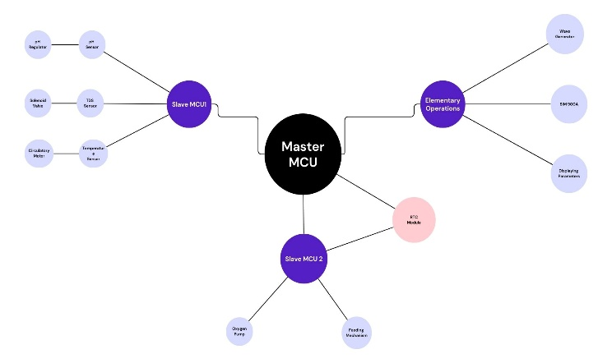
Figure: Block Diagram of System
The block diagram outlines the architecture of an IoT based pearl farming system designed to monitor and regulate critical parameters essential for optimized pearl production. The proposed IoT based pearl farming system is designed to automate and optimize critical processes essential for pearl production by employing a master slave microcontroller architecture integrated with advanced sensors and actuators. The system uses Slave MCU 1 to monitor water parameters such as pH, TDS, and temperature through respective sensors, activating corrective mechanisms like dosing pumps, solenoids, and chillers when thresholds are exceeded. Slave MCU 2 handles oxygen supply and algae feeding, ensuring the oysters’ health and productivity. Data from both slave units are transmitted to the Master MCU, which integrates real time inputs and employs machine learning algorithms to regulate ammonia levels while controlling a 5V relay for operating a 230V submersible pump and synchronizing time sensitive tasks via an RTC module. A SIM900A module facilitates wireless data transmission to a remote monitoring system,enabling real-time supervision and analytics, while local displays show critical water parameters. By automating water quality management, feeding, and circulation, this system reduces manual intervention and enhances efficiency, addressing the challenges of traditional pearl farming. The modular design supports scalability for future integration, making this IoT based solution a significant advancement in precision aquaculture for sustainable and high quality pearl production.

Flowchart Overview
The flowchart represents the automated control system designed for water quality management and optimization, where each stage operates sequentially to maintain optimal conditions for pH, TDS, temperature, and algae feeding. The system is enhanced by machine learning algorithms for predictive maintenance and efficient resource management. Below is a detailed breakdown of each stage, as shown in the flowchart.
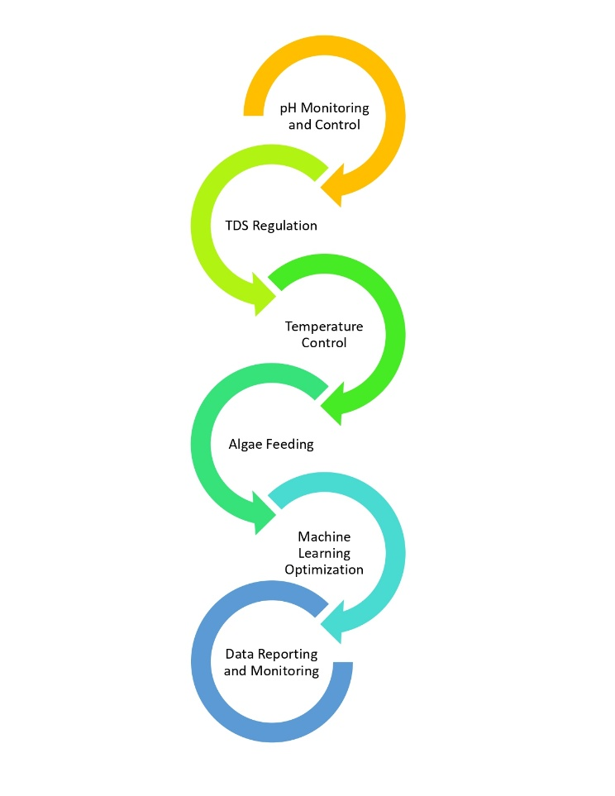

pH Monitering and Control
The first stage involves continuous monitoring of pH levels in the water. As the data is collected by the sensor, it is sent to the controller for comparison with predefined thresholds. If the pH is outside the acceptable range, the dosing pump is activated to correct the pH by adding the necessary chemicals.

TDS Regulation:
In the second phase, the system monitors Total Dissolved Solids (TDS) levels in the water. If the TDS exceeds the safe limit of 500 ppm, the controller initiates the water exchange process by using two pumps: one removes the water from the tank, while the other refills the tank with fresh water to restore TDS balance.

Temperature Control:
The third stage tracks the water's temperature. If it rises above the safe limit (35°C), the controller triggers the chiller to bring the temperature back within the acceptable range. The system ensures continuous temperature regulation to protect the water environment from overheating.

Algae Feeding:
At the fourth stage, the system manages the feeding of algae through a timer controlled algae dispenser. The precise amount of algae is fed at preset intervals, ensuring that the algae supply is consistent and timely.

Machine Learning Optimization:
The fifth stage integrates machine learning algorithms. These algorithms analyze historical and real time data to predict trends and potential issues. This enables the system to optimize adjustments proactively for pH, TDS, and temperature, ensuring smooth and efficient operation without manual intervention.

Data Reporting and Monitoring:
In the final stage, the system compiles all the collected data—pH, TDS, and temperature values—and sends it to the owner. This real time data reporting allows for comprehensive monitoring, enabling the owner to oversee the system's conditions remotely and intervene if necessary.
System Details :
We have implemented a system using three ESP32 microcontrollers, where one serves as the main node responsible for receiving data from the other two nodes and displaying it on a 20x4 I2C LCD, as well as uploading it to an online platform (Blynk) for remote monitoring. In addition to data handling, the main ESP32 also controls solenoid valves based on real-time sensor data, enabling automated regulation of water parameters. The ESP32 was chosen due to its integrated Wi-Fi capability, lightweight design, and low power consumption.
The system utilizes a DFRobot pH sensor with a measurement range of 0 to 14 pH. This sensor features an internal EEPROM to store calibration data. Calibration is initiated with the "enterph" command, which sets the sensor into calibration mode. The "calph" command detects the buffer solution (typically pH 4 or pH 7) and calibrates the sensor accordingly. This calibration data is then stored in EEPROM for future accuracy.
For measuring Total Dissolved Solids (TDS), we use the Keyestudio TDS sensor, which has a measurement range of
0 to 1000 ppm and outputs voltages between 0 and 2.3V, which are interpreted via analog input.

Temperature is monitored using a DS18B20 digital temperature sensor, which communicates via the One-Wire protocol in a master-slave configuration. This sensor provides accurate temperature data digitally, eliminating the need for analog conversion.
The node configuration is as follows:
- Node 1 handles pH and temperature measurements:
  - The pH sensor is connected to GPIO 33 (ADC1 Channel 5).
  - The temperature sensor is connected to GPIO 4 (digital pin).
- Node 2 is dedicated to TDS measurement, with the TDS sensor connected to GPIO 35 (ADC1 Channel 7).
We specifically use ADC1 channels for analog input to avoid conflicts with Wi-Fi functionality, which can occur with ADC2 on the ESP32.
For inter-node communication, we utilize the ESP-NOW protocol, a lightweight and reliable connectionless communication method that allows ESP32 devices to exchange data directly without requiring an external Wi-Fi router. Sensor data collected by Node 1 and Node 2 is sent to the main node, which processes and forwards it to Blynk for remote access.
To manage physical devices, we have integrated relays controlled by the ESP32s. These relays operate various components such as the oxygen pump, wave generator, and solenoid valves. The system can turn these devices on or off automatically based on sensor readings or remote user input.
Additionally, a fourth ESP32 microcontroller is dedicated to toggling the oxygen pump and wave generator. It operates either autonomously or under remote commands, helping regulate aquatic conditions efficiently.
Result Analysis :
The proposed system is designed for intelligent water quality monitoring and automated control using multiple ESP32 microcontrollers. The architecture comprises two sensing nodes, one main processing node, and one control node for environmental actuation. This distributed approach ensures efficient data acquisition, real-time decision-making, and reliable actuation.
The environmental parameters, including pH, Total Dissolved Solids (TDS), and temperature, are continuously monitored by Node 1 and Node 2. These two nodes operate independently to collect and transmit sensor readings to the main ESP32 node, which serves as the system’s central processing unit. Node 1 handles the pH and temperature sensors, while Node 2 is dedicated to TDS monitoring.
All sensor readings are transmitted to the main node using the ESP-NOW protocol at regular intervals of every 5 seconds. ESP-NOW was chosen due to its lightweight, low-latency, and connectionless communication model, which allows multiple ESP32 boards to exchange data reliably without the need for a Wi-Fi router. This is especially beneficial for IoT applications in isolated or field-based environments.
Upon receiving the data, the main node performs real-time analysis to determine whether the water conditions are within acceptable thresholds. Specifically, a water exchange process
Is automatically initiated if any of the following conditions are met :
- The pH value drops below 5.9
- The pH exceeds 8.0
- The TDS level exceeds 550 ppm
When such anomalies are detected, the system first activates a solenoid valve via a relay module to drain the existing water from the tank. Once the draining process is completed, another solenoid valve is activated to refill the tank with fresh water. Both solenoid valves are connected to the main controller and operate through relay-driven switching, ensuring electrical isolation and safe control of high-power devices.
The decision-making logic is implemented through efficient conditional programming structures (if-else), which are executed every time new data is received. This ensures a responsive and adaptive control mechanism, capable of reacting instantly to fluctuating environmental parameters.
In addition to decision-making and local actuation, the main node also serves as the gateway to cloud services. To reduce data congestion and conserve bandwidth, the system is configured to upload sensor data to the Blynk platform every hour. This enables remote users to monitor tank conditions in real time and review historical trends through Blynk’s intuitive dashboard interface.
A fourth ESP32 node is deployed exclusively for environmental actuation, specifically to manage the oxygen pump and wave generator, which are crucial for maintaining optimal aquatic conditions in pearl farming systems. This node is programmed with timed operations:
- The oxygen pump is toggled every 5 minutes to ensure consistent aeration.
- The wave generator is activated at 30-second intervals to create controlled water movement.
Both devices are controlled using relay modules, which allow for precise switching while maintaining electrical safety. These environmental controls play a vital role in creating a healthy and dynamic aquatic habitat, which is essential for pearl development and overall aquatic organism well-being.

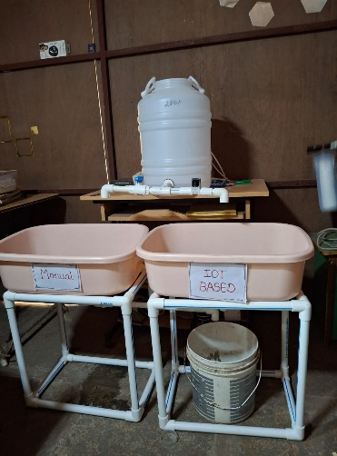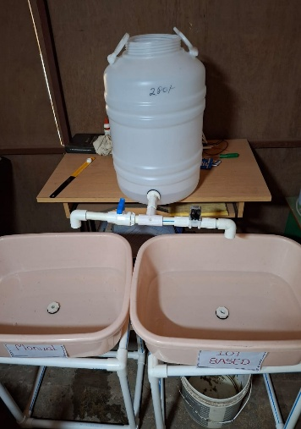

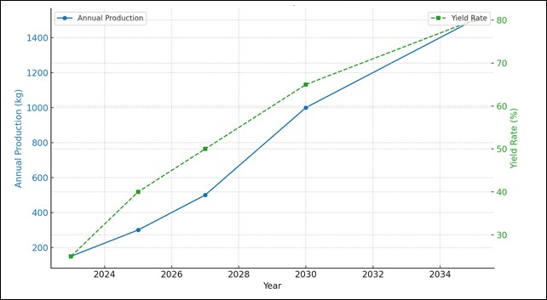
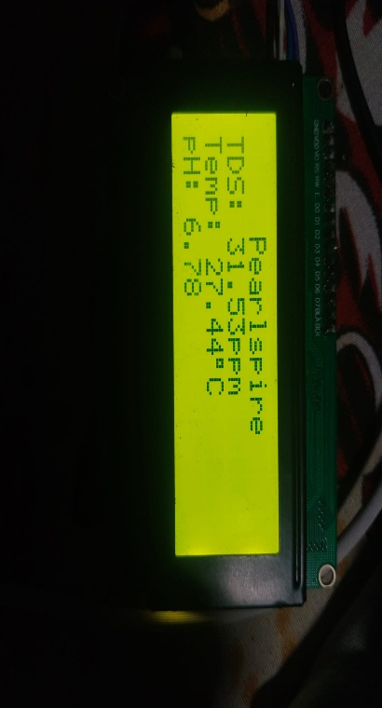

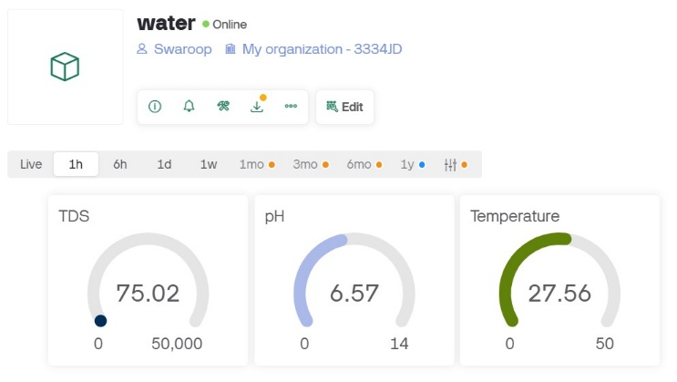

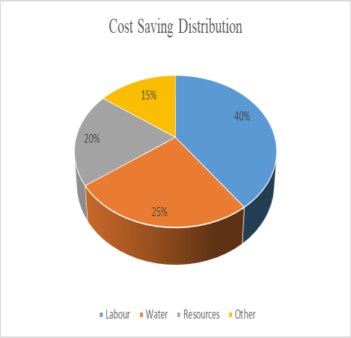
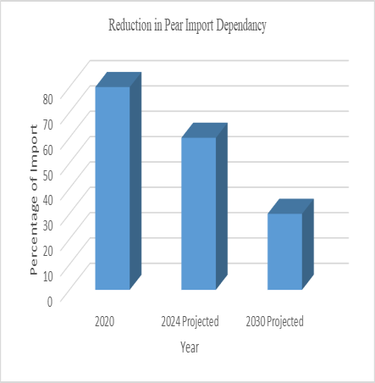
Future Of Smart Pearl Farming
Figure : Impact of Smart Pearl Farming on Cost Saving and Pearl Import Statistics
The implementation of smart pearl farming through IoT-based systems is expected to have a significant impact on reducing dependency on pearl imports and optimizing operational costs. The bar chart shows a projected reduction
in pearl import dependency, with imports decreasing from 80% in 2020 to around 50% by 2024 and further dropping to less than 30% by 2030. This demonstrates the potential of localized smart farming technologies to boost domestic pearl production and reduce reliance on foreign sources. The pie chart highlights the cost savings distribution achieved by smart pearl farming, with labor savings making up the largest portion at 40%, followed by water savings at 25%, savings in resources at 20%, and miscellaneous operational costs (15%). Automating labor-intensive tasks like water quality monitoring and algae feeding reduces human resource requirements, while optimized resource usage ensures minimal wastage of water and nutrients. These savings enhance the profitability of pearl farming and make it a more viable option for small-scale farmers.

Figure: Projected Impact of IoT and ML Adoption on Pearl Production and Yield Rates (2023–2035)
Figure X presents the projected impact of adopting IoT and ML-based solutions in India’s pearl farming industry, addressing the limitations of traditional methods. Currently, traditional practices are constrained by low yield rates (20–30%), inefficiencies in monitoring, and the heavy reliance on manual intervention, which restricts scalability and progress. The graph highlights the potential improvements achievable through technology adoption: yield rates could rise from 25% in 2023 to 80% by 2035, and annual pearl production might increase tenfold, from 150 kg to 1,500 kg. These predictions emphasize how IoT-based real-time monitoring and ML-driven analytics can overcome the inefficiencies of manual processes, paving the way for optimized operations, better resource utilization, and sustainable growth in pearl farming.

Conclusion
The IoT-Based Pearl Farm Health Regulator marks a paradigm shift in pearl farming by addressing inefficiencies and introducing cutting-edge technology. By automating water quality management and feeding, the system ensures higher productivity and profitability while reducing labor dependency. This innovation not only enhances India’s domestic production capabilities but also positions the country as a strong competitor in the global pearl market. Additionally, its sustainable approach aligns with global environmental goals, ensuring long-term viability for the industry. As a transformative solution, the system empowers farmers to achieve economic resilience and ecological balance, paving the way for a thriving, modernized pearl farming sector.

Funding Information
This research was supported by the Technology Innovation Hub (TIH) at IIT Bombay, through a grant of ₹6,00,000. The authors sincerely appreciate the financial support, which has played a crucial role in facilitating the successful development and execution of this project.

References
- M. Singh, K. S. Sahoo, A. H. Gandomi, “An Intelligent IoT-Based Data Analytics for Freshwater Recirculating Aquaculture System,” IEEE Internet of Things Journal, 2023.
- M.-C. Chiu, W.-M. Yan, S. A. Bhat, N.-F. Huang, “Development of Smart Aquaculture Farm Management System Using IoT and AI-Based Surrogate Models,” Journal of Agriculture and Food Research, 2022.
- D. Kumar V., E. M., M. Sam M., L. R., “Blynk-Based Aquaculture Monitoring System Using IoT,” World Journal of Advanced Engineering Technology and Sciences, 2023.
- Neelambika, S. G., P. B. C., “Mastering Pearl Cultivation: An Exploration of Freshwater Pearl Farming and Harvesting,” KRISHI SCIENCE, 2024.
- M. Singh, K. S. Sahoo, A. Nayyar, “Sustainable IoT Solution for Freshwater Aquaculture Management,” IEEE Sensors Journal, 2022.
- S. Saurabh, S. Pradhan, S. Suman, “Recent Trends in Freshwater Pearl Farming in India,” Intech Open, 2022.
- A. Santhiya, T. A., M. S. Vishnupriya, “Sustainable IoT Solution for Freshwater Aquaculture Using FPGA,” International Journal of Research Publication and Reviews, 2023.
- J. Liu, L. Shu, X. Lu, Y. Liu, “Survey of Intelligent Agricultural IoT Based on 5G,” Electronics, 2022.
- H. Farooq, H. U. Rehman, A. Javed, M. Shoukat, S. Dudley, “A Review on Smart IoT-Based Farming,” Annals of Emerging Technologies in Computing, 2020.
- N. M. Mohamed, “Smart Aquaculture: IoT-Enabled Monitoring and Management of Water Quality for Mahseer Fish Farming,” Seventh Sense Research Group, 2024.
- S. Birunagi, S. Patil, N. Saini, D. Katkar, “Pearl Farming: A Review of Farming in

the Future,” International Journal of Research in Agronomy, 2024.
- S. Saurabh, S. Pradhan, S. Suman, “Recent Trends in Freshwater Pearl Farming in India,” Update on Malacology, IntechOpen, 2022.

